1) Write a Python program for binary search.

PROGRAM:

def binary_search(arr,x):

arr.sort()

left, right = 0, len(arr) - 1

while left <= right:

mid = (left + right) // 2

if arr[mid] == x:

return True

elif arr[mid] < x:

left = mid + 1

else:

right = mid - 1

return False

numbers = list(map(int, input().split(',')))

target = int(input())

result = binary_search(numbers, target)

print(result)

OUTPUT:

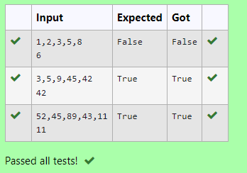

2) Given an list, find peak element in it. A peak element is an element that is greater than its neighbors.

An element a[i] is a peak element if

A[i-1] <= A[i] >=a[i+1] for middle elements. [0<i<n-1]

A[i-1] <= A[i] for last element [i=n-1]

A[i]>=A[i+1] for first element [i=0]

**Input Format**

The first line contains a single integer n , the length of A .  
The second line contains n space-separated integers,A[i].

**Output Format**

**Print** peak numbers separated by space.

**Sample Input**

5

8 9 10 2 6

**Sample Output**

10 6

PROGRAM:

def find_peaks(arr):

n = len(arr)

peaks = []

if n > 0 and (n == 1 or arr[0] >= arr[1]):

peaks.append(arr[0])

for i in range(1, n-1):

if arr[i] >= arr[i-1] and arr[i] >= arr[i+1]:

peaks.append(arr[i])

if n > 1 and arr[n-1] >= arr[n-2]:

peaks.append(arr[n-1])

return peaks

if __name__ == "__main__":

n = int(input())

arr = list(map(int, input().split()))

peaks = find_peaks(arr)

print(" ".join(map(str, peaks)))

OUTPUT:

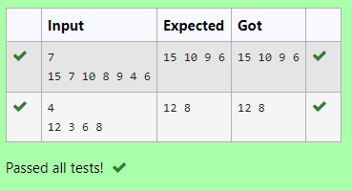

3) Bubble Sort is the simplest sorting algorithm that works by repeatedly swapping the adjacent elements if they are in wrong order. You read an list of numbers. You need to arrange the elements in ascending order and print the result. The sorting should be done using bubble sort.

**Input Format:**The first line reads the number of elements in the array. The second line reads the array elements one by one.

**Output Format:** The output should be a sorted list.

PROGRAM:

def merge_sort(arr):

if len(arr) > 1:

mid = len(arr) // 2

left_half = arr[:mid]

right_half = arr[mid:]

merge_sort(left_half)

merge_sort(right_half)

i = j = k = 0

while i < len(left_half) and j < len(right_half):

if left_half[i] < right_half[j]:

arr[k] = left_half[i]

i += 1

else:

arr[k] = right_half[j]

j += 1

k += 1

while i < len(left_half):

arr[k] = left_half[i]

i += 1

k += 1

while j < len(right_half):

arr[k] = right_half[j]

j += 1

k += 1

n = int(input( ))

arr = list(map(int, input().split()))

merge_sort(arr)

print(' '.join(map(str, arr)))

OUTPUT:

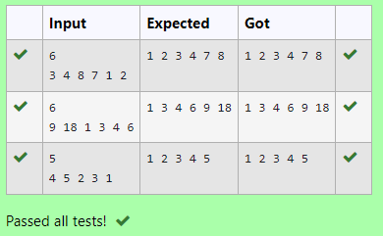

4) To find the frequency of numbers in a list and display in sorted order.

**Constraints:**

1<=n, arr[i]<=100

**Input:**

1 68 79 4 90 68 1 4 5

**output:**

 1 2

 4 2

 5 1

 68 2

 79 1

90 1

PROGRAM:

def find_frequencies(arr):

frequency_dict = {}

for number in arr:

if number in frequency_dict:

frequency_dict[number] += 1

else:

frequency_dict[number] = 1

sorted_frequency = sorted(frequency_dict.items())

return sorted_frequency

if __name__ == "__main__":

arr = list(map(int, input().split()))

frequencies = find_frequencies(arr)

for number, frequency in frequencies:

print(number,frequency)

OUTPUT:

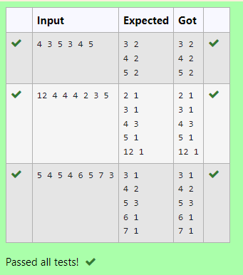

5) Given an listof integers, sort the array in ascending order using the *Bubble Sort* algorithm above. Once sorted, print the following three lines:

1.      List is sorted in numSwaps swaps., where numSwaps is the number of swaps that took place.

2.      First Element: firstElement, the  *first* element in the sorted list.

3.      Last Element: lastElement, the *last* element in the sorted list.

For example, given a worst-case but small array to sort: a=[6,4,1]. It took  3 swaps to sort the array. Output would be

Array is sorted in 3 swaps.

First Element: 1

Last Element: 6

**Input Format**

The first line contains an integer,n , the size of the list a .  
The second line contains  n,  space-separated integers a[i].

**Constraints**

·         2<=n<=600

·         1<=a[i]<=2x106.

**Output Format**

You must print the following three lines of output:

1.      List is sorted in numSwaps swaps., where numSwaps is the number of swaps that took place.

2.      First Element: firstElement, the  *first* element in the sorted list.

3.      Last Element: lastElement, the *last* element in the sorted list.

**Sample Input 0**

3

1 2 3

**Sample Output 0**

List is sorted in 0 swaps.

First Element: 1

Last Element: 3

PROGRAM:

def bubbleSort(arr):

n = len(arr)

numSwaps = 0

for i in range(n):

swapped = False

for j in range(n - i - 1):

if arr[j] > arr[j + 1]:

arr[j], arr[j + 1] = arr[j + 1], arr[j]

swapped = True

numSwaps += 1

# If no swaps occurred in this pass, the list is already sorted

if not swapped:

break

return numSwaps

# Input

n = int(input())

arr = list(map(int, input().split()))

# Sort the array and get the number of swaps

numSwaps = bubbleSort(arr)

# Print the required information

print(f"List is sorted in {numSwaps} swaps.")

print(f"First Element: {arr[0]}")

print(f"Last Element: {arr[-1]}")

OUTPUT:

